**ACTIVITY 3: - Develop Static Website Sign-up/Sign-In using HTML concept**

**Name: - Raj R Sharma**

This is my first static website only using HTML concepts.

[Except body background color]

my website logo is TECH SABERTOOTH.

follow this website HOME>ABOUTUS>SIGNUP>SIGNIN>CONTACTUS

In this website I create 5 pages.

1. 1st is home page. inside the homepage I demonstrate about teamwork.
2. 2nd page is about signup page. in this signup page the members are able signup. there is a common thing like First Name, Last Name, Email id, Password, Date of birth and gender.
3. 3rd page is about sign in page. in this only member who did signup or registered are only accepted here. the members are able to sign up with google and Facebook.
4. 4th page is about ABOUTUS page. in this page I create about my company details like what is TECHNICAL SABERTOOTH PVT. LTD., about our goals, which types of fields, about what makes us different.
5. 5th page is about contact us page. in this page which members want to they are contact us easily using this page.

**OUTPUT FILES of Code and web page-:**

**Home Page:-**

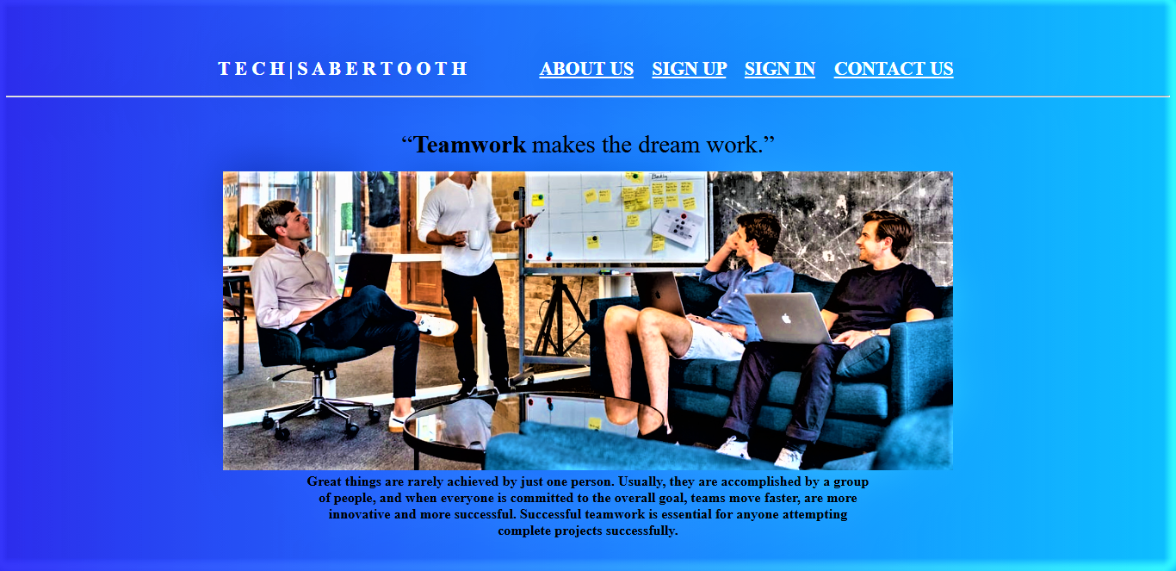

**(HOME PAGE)**

**Code of html file:-**

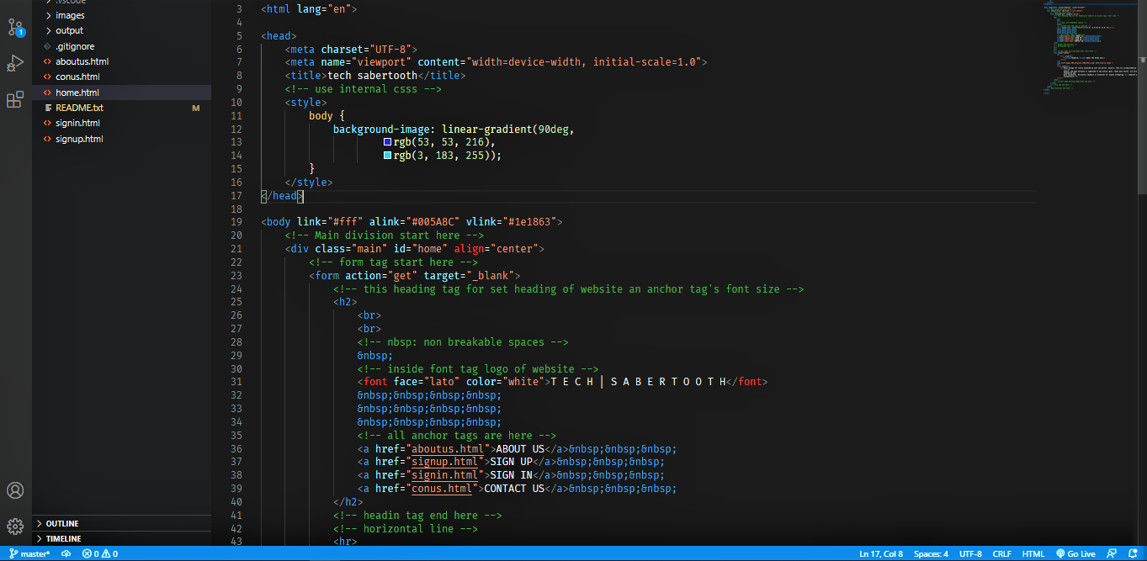

**(Code of Homepage 1.0)**

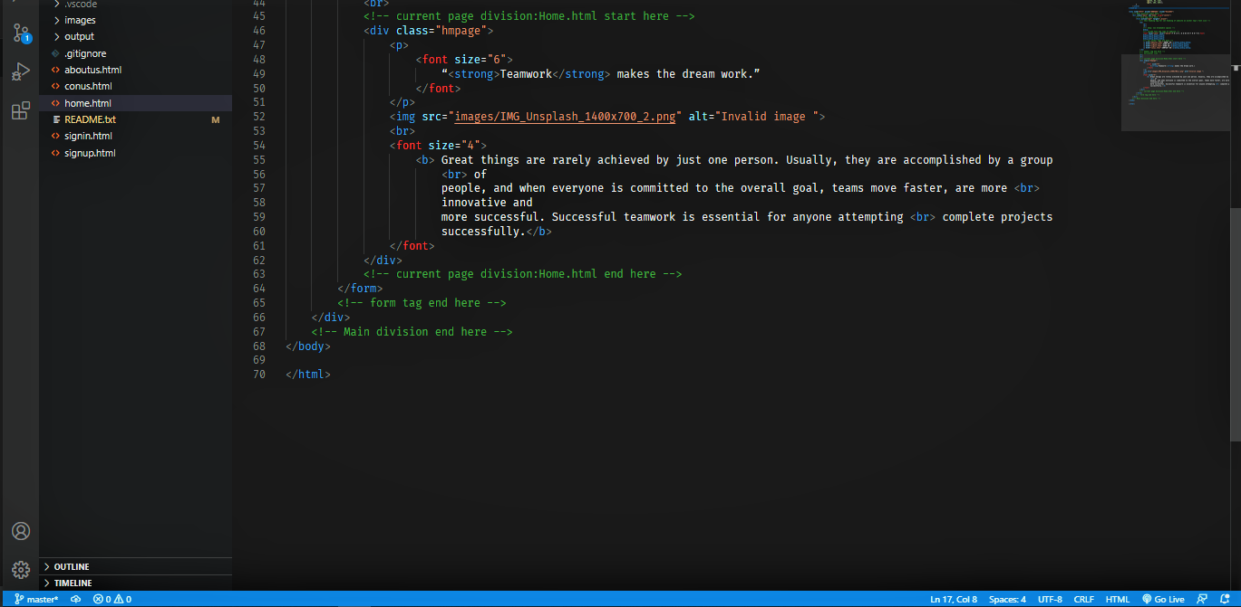

**(code of Home page 2.0)**

**ABOUT US page: -**

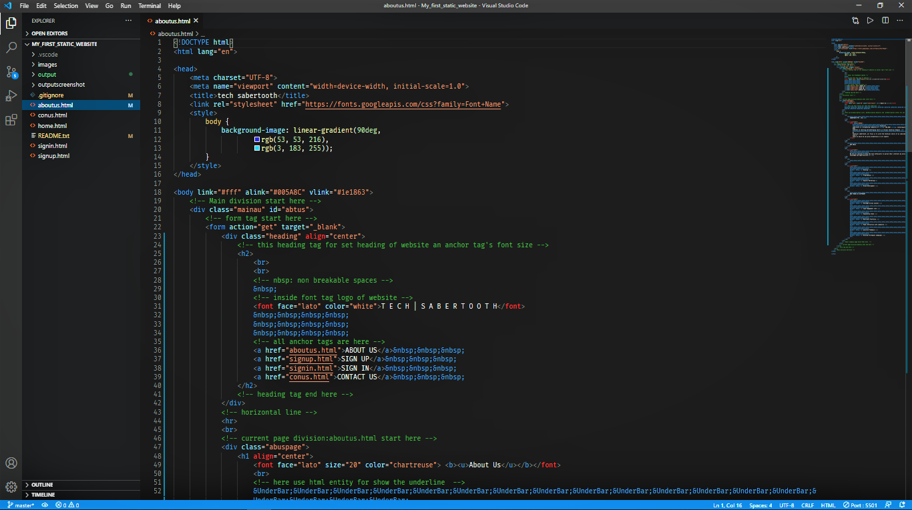

**(code of about us page 2.0)**

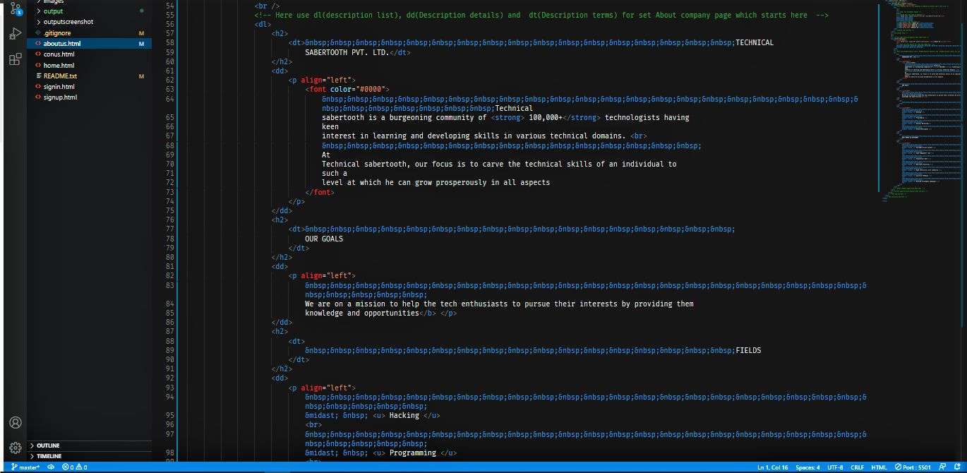

**(code of about us page 2.1)**

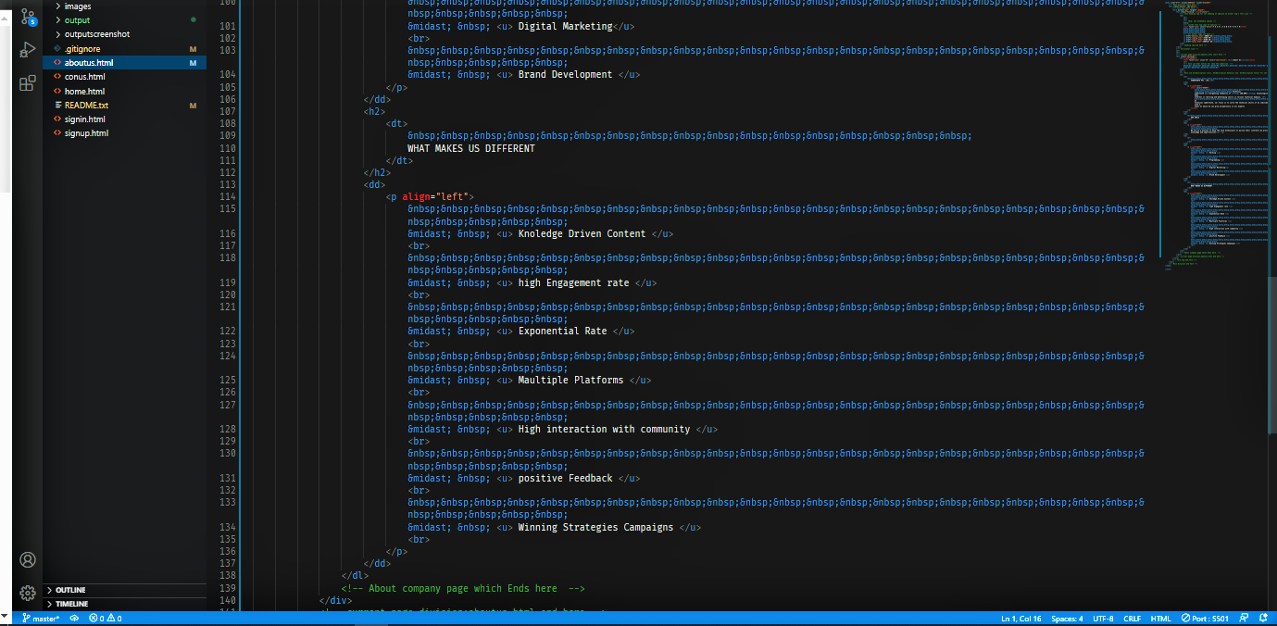

**(code of about us page 2.2)**

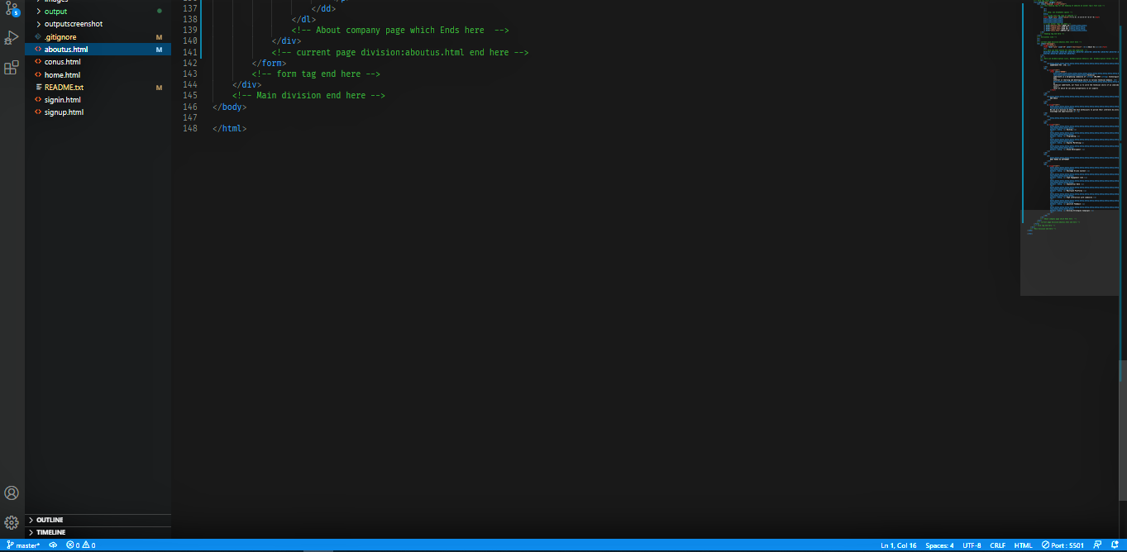

**(code of about us page 2.3)**

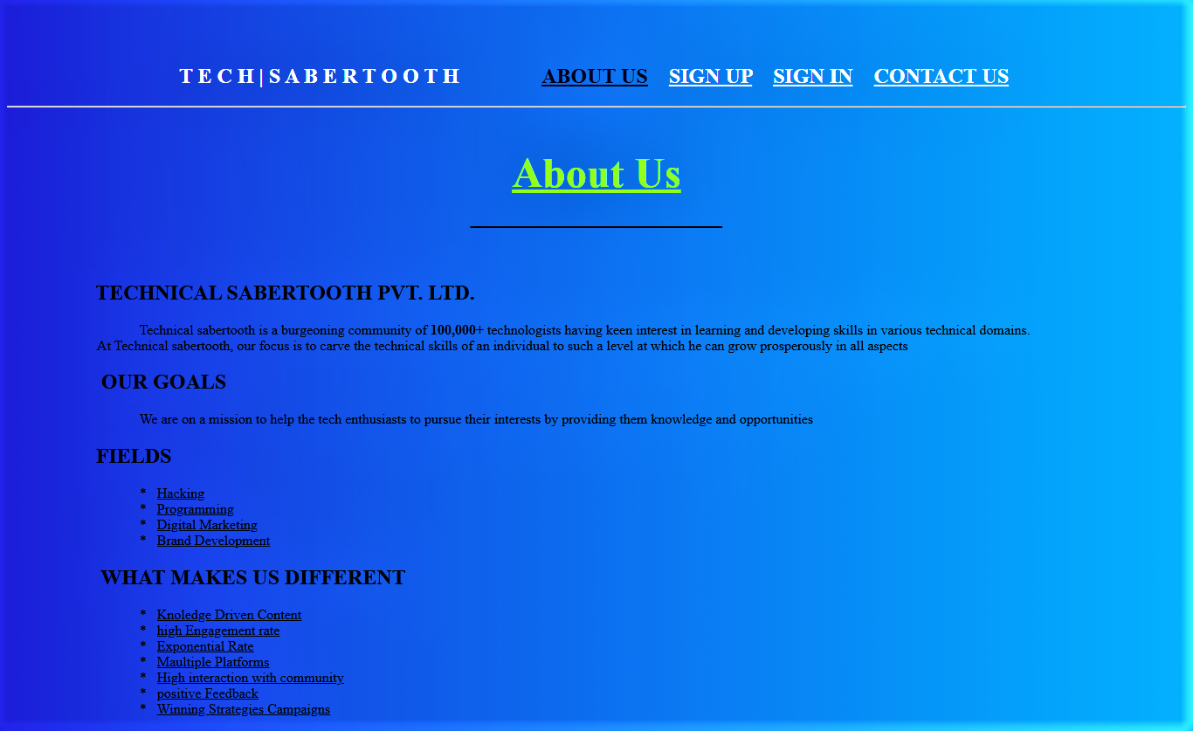

**(about us page output)**

**Signup page: -**

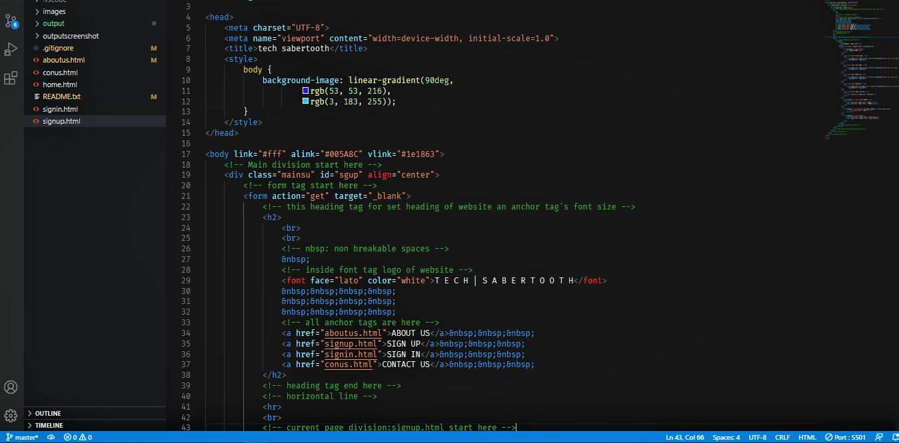

**(code of sign up page 3.0)**

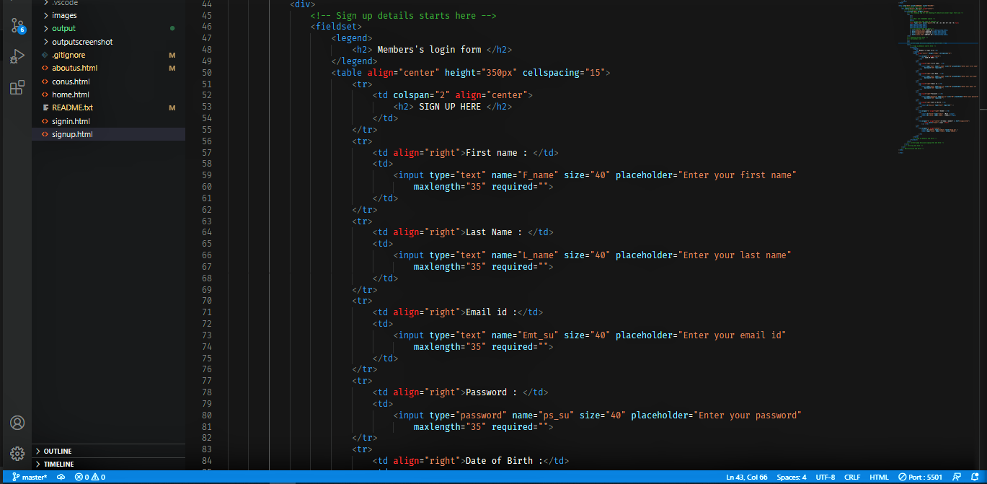

**(code of sign up page 3.1)**

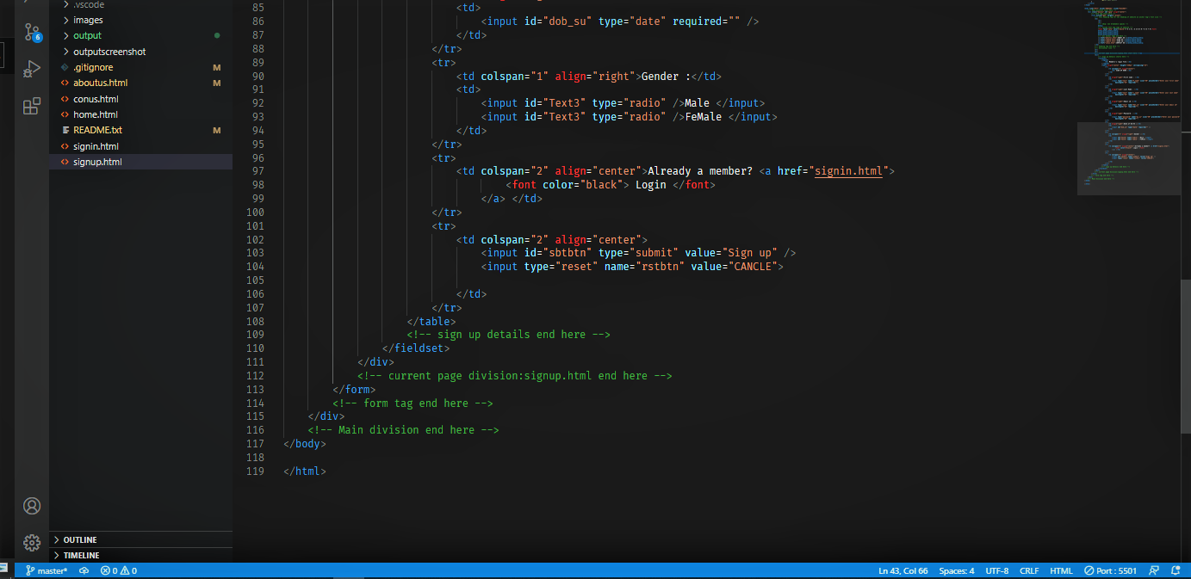

**(code of sign up page 3.2)**

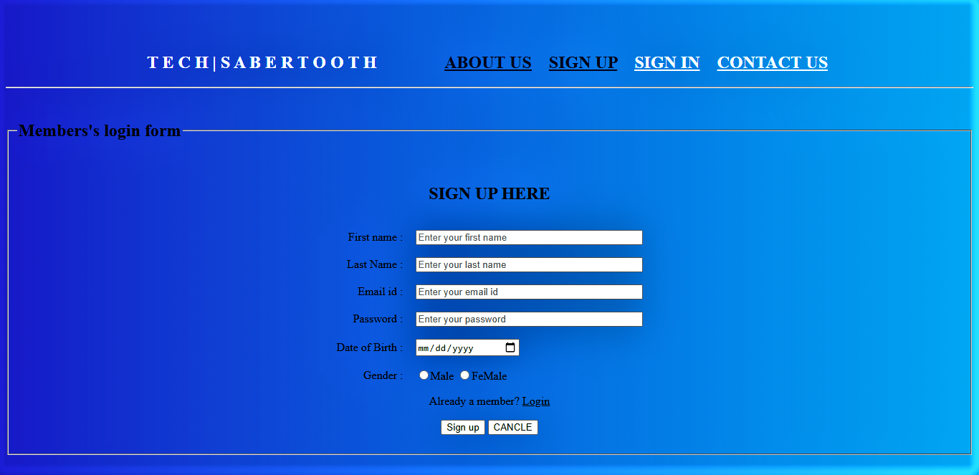

**(signup page output)**

**Sign in page: -**

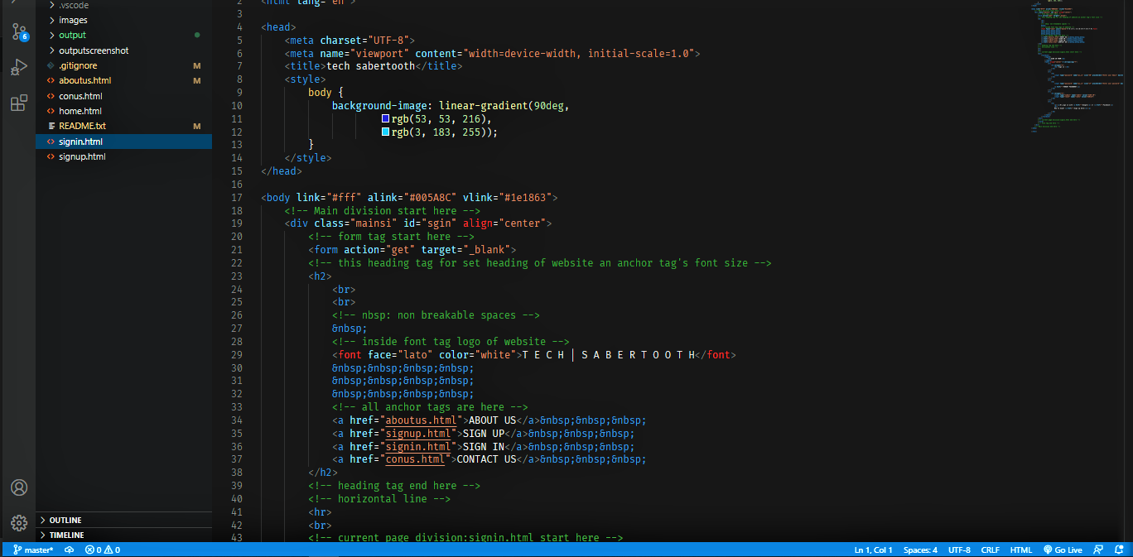

**(code of sign in page 4.0)**

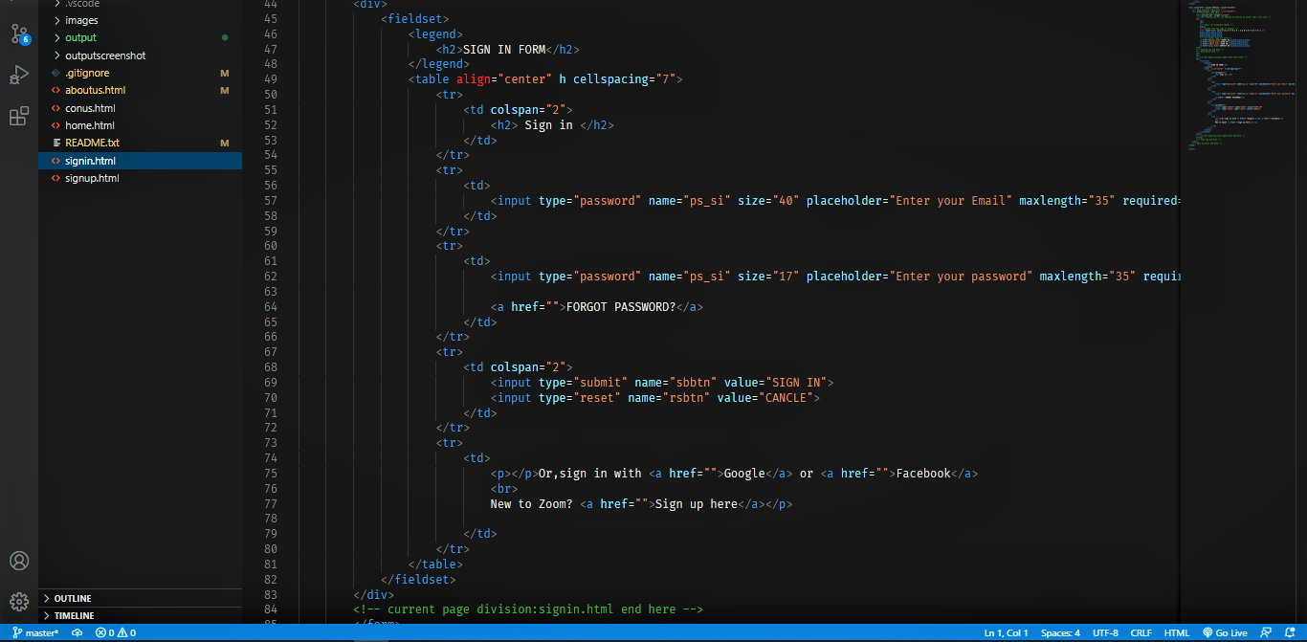

**(code of sign in page 4.1)**

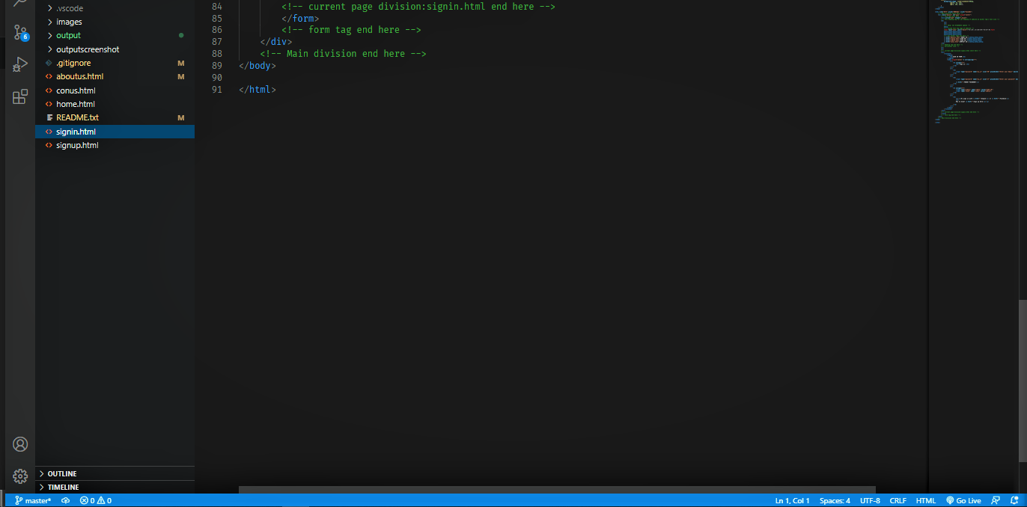

**(code of sign in page 4.2)**

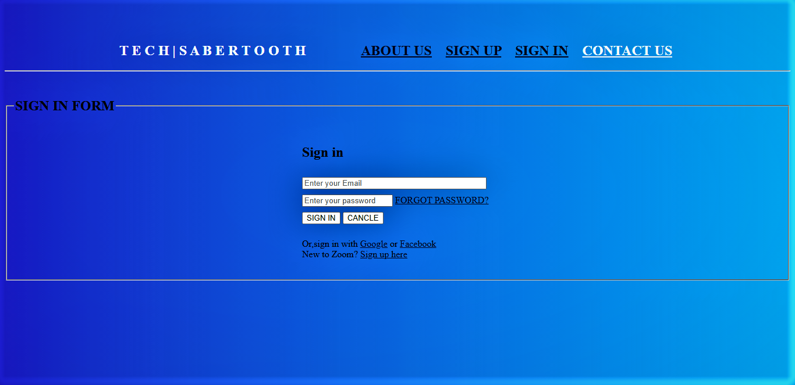

**(Sign in page output)**

**Contact us page: -**

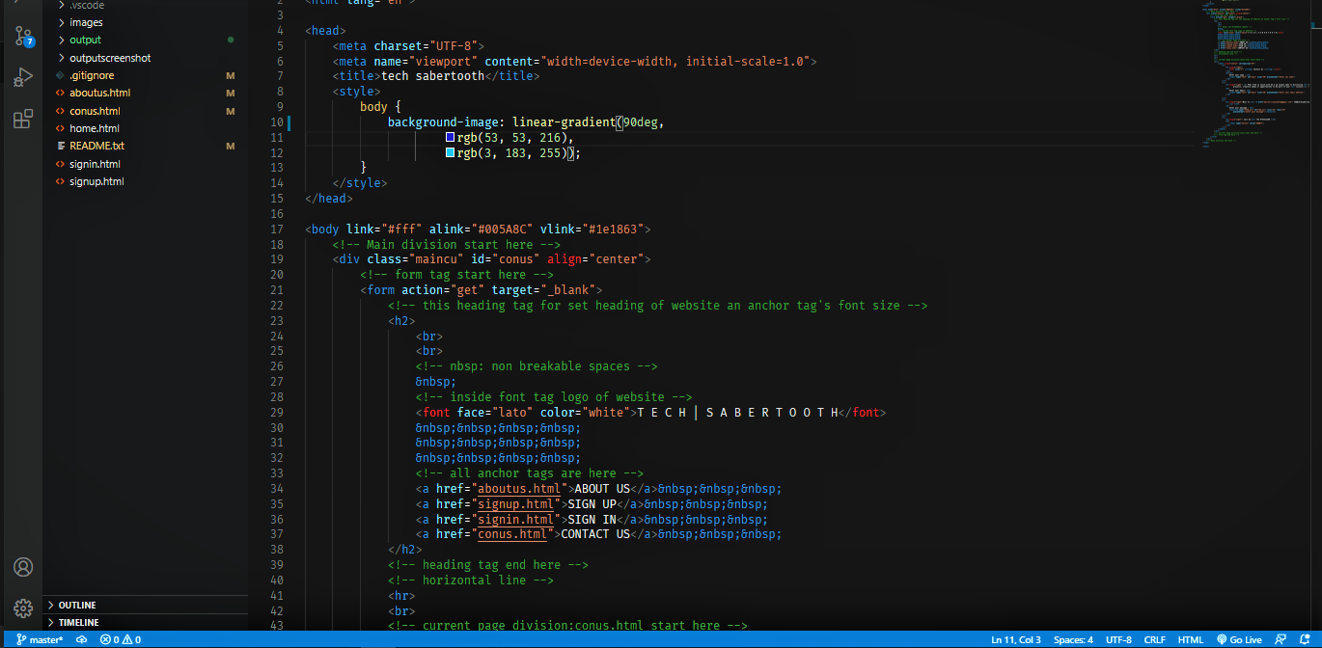

**(code Contact us page 5.0)**

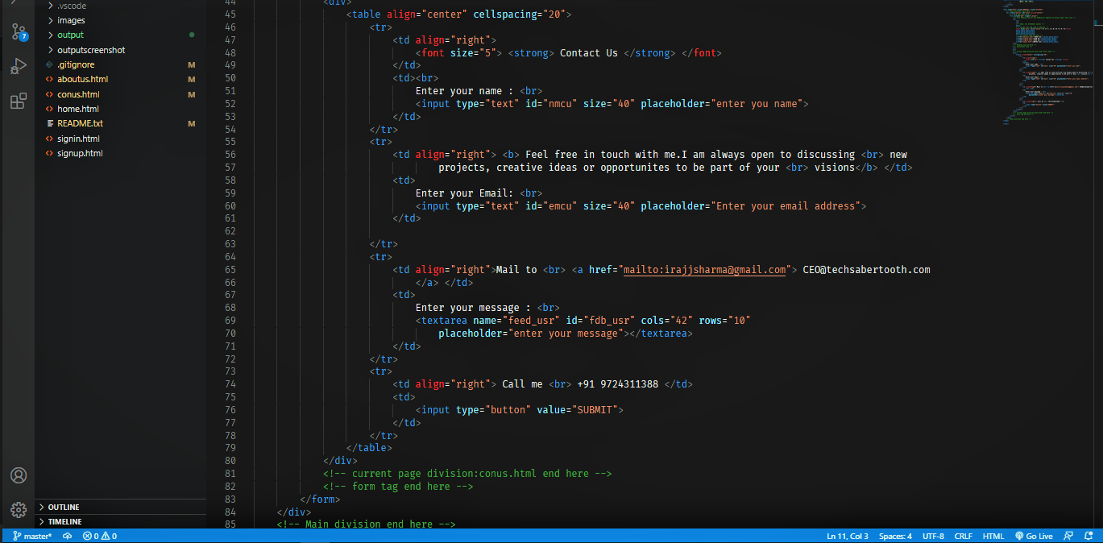

**(code Contact us page 5.1)**

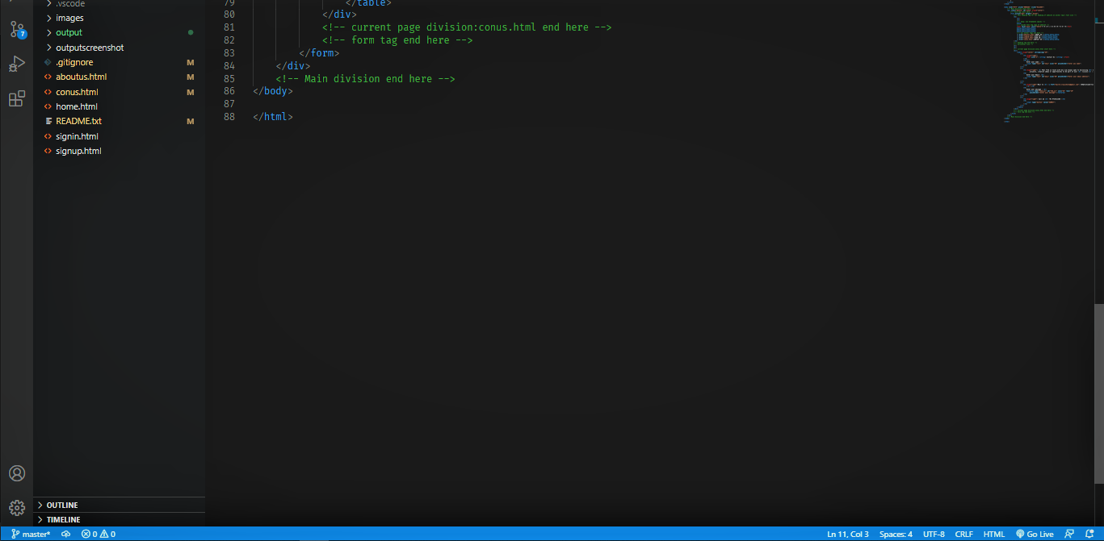

**(code Contact us page 5.2)**

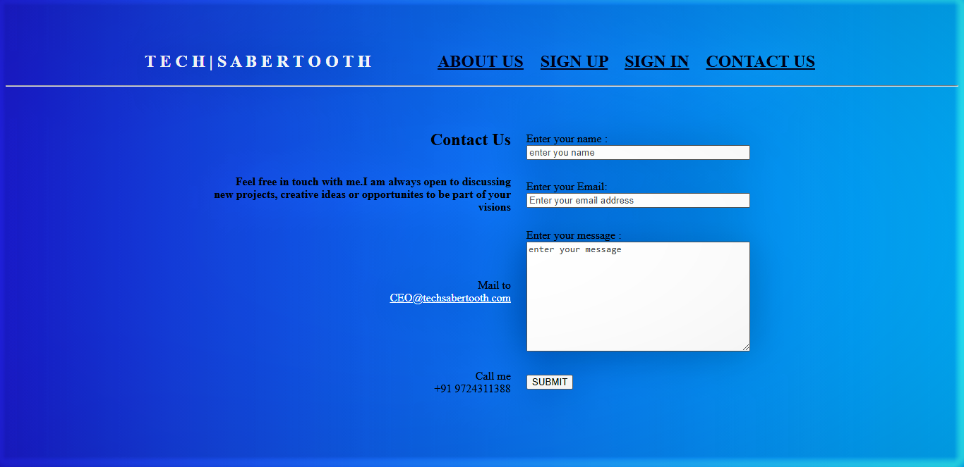

**(Contact us page output)**